Rolling correlation: EURUSD and USDCHF
Method 05 / daily log returns / windows 20, 60, 100 / Short watchlist

Study setup
Logical pair: EURUSD , USDCHF
Broker symbols: EURUSD_i , USDCHF_i
Tier: Short watchlist (short_watchlist)
Snapshot: 2026-11-03_majors_alpari_D1
Timeframe: D1
Matched return window: 1999-01-05 to 2026-11-02 (UTC bar dates)
Matched return count (rows before rolling): 7186
Dropped unfinished last bar dated 2026-11-03 UTC after a tick-volume check against the prior complete day.
Rolling windows W: 20, 60, 100 trading days
Live-shaped n for each score: n = W (not the full history length)
Complete matched rows (CSV): EURUSD-USDCHF_Rolling_D1.csv
Complete matched rows (HTML): EURUSD-USDCHF_Rolling_D1_data.html

Method carried forward
Rolling Pearson r is computed on matched daily log returns of close, ln(close_t / close_t-1), in the broker quote direction. Quotes are not inverted. For each day t with a full window, r_W uses the last W matched return pairs ending at t. That live-shaped sample size is W (20, 60, or 100), not the full multi-year history. The first W-1 days have no score. r is symmetric under swap of the two symbols. A high |r| in one window does not prove cause, lead-lag, or a trading signal. Short windows are noisier; long windows are slower to reflect a break.
How to read a live day: after both daily candles close, the newest r_20 uses the last 20 matched log returns, r_60 the last 60, and r_100 the last 100. Compare those three to each other and to the full-sample baseline below. A break is when the short window moves far from the baseline or flips sign while the baseline was meaningful.

Full-sample Pearson baseline (method 01 v001)
Copied full-sample Pearson r for EURUSD-USDCHF: -0.749204. This is a historical average link, not the live state.

Rolling results
W | latest_r | mean | median | min | max | std | pct_|r|>=0.4 | pct_|r|>=0.7 | n_roll
20 | -0.728572 | -0.833468 | -0.890706 | -0.999488 | 0.556597 | 0.174392 | 97.11 | 84.48 | 7167
60 | -0.691696 | -0.829157 | -0.869518 | -0.992868 | 0.142008 | 0.161912 | 97.56 | 84.86 | 7127
100 | -0.755247 | -0.824165 | -0.861018 | -0.992633 | 0.043206 | 0.160609 | 97.15 | 85.86 | 7087
n_roll is the number of days that had a complete window. pct_|r|>=0.4 and pct_|r|>=0.7 are the share of those days where the absolute rolling correlation cleared the threshold.

Conclusion
For EURUSD and USDCHF, full-sample Pearson baseline r=-0.7492. Latest rolling scores: r_20=-0.7286, r_60=-0.6917, r_100=-0.7552. Stability: moderate window-to-window variation. Agreement with baseline: r_20=-0.729 near baseline; r_60=-0.692 near baseline; r_100=-0.755 near baseline. Tier line: watch — priority pair; monitor r_20 vs r_60/r_100 each day. This is a monitoring summary, not a trade signal.

What to look at in this file next time
1) Latest r_20 vs r_60 vs r_100 in the results table. 2) Whether short-window latest has the same sign as the baseline. 3) The rolling chart for stretches where |r| collapsed. 4) The CSV if you need a different chart later.

Charts
Rolling Pearson r (20 / 60 / 100)
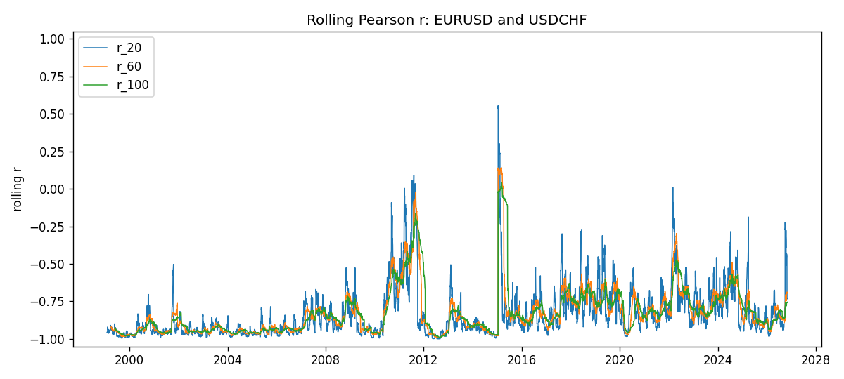
Daily closes

Daily log returns
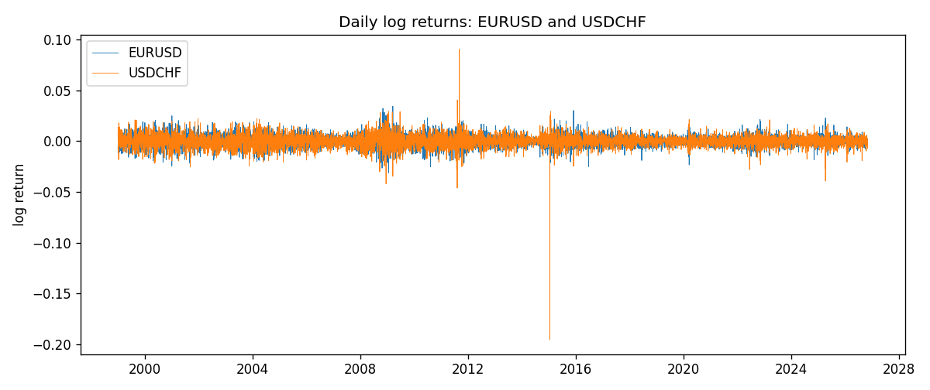

Data report
Every matched row with r_20, r_60, and r_100 is in the sibling CSV and HTML. This Word section holds column summaries and the first and last 15 rows of the rolling table.
Columns: time, EURUSD_close, USDCHF_close, EURUSD_tick_volume, USDCHF_tick_volume, EURUSD_log_return, USDCHF_log_return, r_20, r_60, r_100
Column summaries
column | count | mean | std | min | 25% | 50% | 75% | max
EURUSD_close | 7186 | 1.18158 | 0.150805 | 0.8267 | 1.08609 | 1.16619 | 1.2941 | 1.5997
USDCHF_close | 7186 | 1.09744 | 0.252125 | 0.72025 | 0.920795 | 0.98995 | 1.23752 | 1.8217
EURUSD_tick_volume | 7186 | 103208 | 173534 | 218 | 9426 | 52774.5 | 99579.8 | 1.47163e+06
USDCHF_tick_volume | 7186 | 74325.1 | 113490 | 18 | 12800 | 40232.5 | 70435.2 | 858589
EURUSD_log_return | 7186 | -3.06e-06 | 0.00580427 | -0.0312382 | -0.00324267 | 0 | 0.00325778 | 0.0343318
USDCHF_log_return | 7186 | -6.921e-05 | 0.00659379 | -0.195457 | -0.00335085 | 8.077e-05 | 0.003323 | 0.0905136
r_20 | 7167 | -0.833468 | 0.174392 | -0.999488 | -0.948751 | -0.890706 | -0.780416 | 0.556597
r_60 | 7127 | -0.829157 | 0.161912 | -0.992868 | -0.94243 | -0.869518 | -0.775012 | 0.142008
r_100 | 7087 | -0.824165 | 0.160609 | -0.992633 | -0.938859 | -0.861018 | -0.770468 | 0.0432064
First 15 matched rows
time | EURUSD_close | USDCHF_close | EURUSD_log_return | USDCHF_log_return | r_20 | r_60 | r_100
1999-01-05 | 1.1758 | 1.3724 | -0.00483605 | 0.00394247
1999-01-06 | 1.1623 | 1.3912 | -0.011548 | 0.0136057
1999-01-07 | 1.1712 | 1.3782 | 0.00762806 | -0.00938838
1999-01-08 | 1.1585 | 1.3935 | -0.0109028 | 0.0110403
1999-01-11 | 1.1503 | 1.4009 | -0.00710329 | 0.00529632
1999-01-12 | 1.1555 | 1.3872 | 0.00451037 | -0.00982756
1999-01-13 | 1.1681 | 1.3621 | 0.0108453 | -0.0182597
1999-01-14 | 1.1681 | 1.3588 | 0 | -0.00242567
1999-01-15 | 1.1563 | 1.3834 | -0.0101532 | 0.0179423
1999-01-18 | 1.1605 | 1.379 | 0.00362569 | -0.00318564
1999-01-19 | 1.1603 | 1.3789 | -0.000172354 | -7.25189e-05
1999-01-20 | 1.1566 | 1.3889 | -0.00319393 | 0.00722599
1999-01-21 | 1.1601 | 1.3836 | 0.00302154 | -0.00382327
1999-01-22 | 1.1587 | 1.3834 | -0.00120752 | -0.000144561
1999-01-25 | 1.1552 | 1.3868 | -0.0030252 | 0.0024547
Last 15 matched rows
time | EURUSD_close | USDCHF_close | EURUSD_log_return | USDCHF_log_return | r_20 | r_60 | r_100
2026-10-13 | 1.11965 | 0.83244 | 0.0037403 | -0.00249556 | -0.392568 | -0.712907 | -0.765639
2026-10-14 | 1.11545 | 0.83489 | -0.00375823 | 0.00293883 | -0.276246 | -0.719527 | -0.766323
2026-10-15 | 1.12172 | 0.82676 | 0.00560531 | -0.00978553 | -0.463844 | -0.736193 | -0.775253
2026-10-16 | 1.12371 | 0.82377 | 0.00177249 | -0.00362308 | -0.474772 | -0.738218 | -0.776813
2026-10-19 | 1.12086 | 0.82677 | -0.00253946 | 0.00363518 | -0.487305 | -0.741028 | -0.778696
2026-10-20 | 1.12354 | 0.8246 | 0.00238817 | -0.00262812 | -0.508722 | -0.74527 | -0.78005
2026-10-21 | 1.12318 | 0.82427 | -0.000320467 | -0.000400274 | -0.452318 | -0.731968 | -0.779025
2026-10-22 | 1.12139 | 0.82032 | -0.00159496 | -0.00480364 | -0.4331 | -0.693952 | -0.767373
2026-10-23 | 1.11989 | 0.82497 | -0.00133852 | 0.00565251 | -0.433888 | -0.698712 | -0.755502
2026-10-26 | 1.11735 | 0.82649 | -0.00227066 | 0.0018408 | -0.437712 | -0.696297 | -0.758626
2026-10-27 | 1.11272 | 0.82865 | -0.00415234 | 0.00261005 | -0.450478 | -0.695111 | -0.758907
2026-10-28 | 1.1152 | 0.82781 | 0.00222629 | -0.00101421 | -0.450309 | -0.692456 | -0.759126
2026-10-29 | 1.11772 | 0.82379 | 0.00225714 | -0.00486802 | -0.734133 | -0.695735 | -0.756107
2026-10-30 | 1.11644 | 0.82438 | -0.00114584 | 0.000715946 | -0.733102 | -0.687236 | -0.756309
2026-11-02 | 1.11881 | 0.81851 | 0.00212057 | -0.00714597 | -0.728572 | -0.691696 | -0.755247

